Self-Rhyme (Auto-Rhyme)

🔁 What is Self-Rhyme (Auto-Rhyme)
# Source: Chatgpt (GPT-4-turbo) at [8/2/2025]
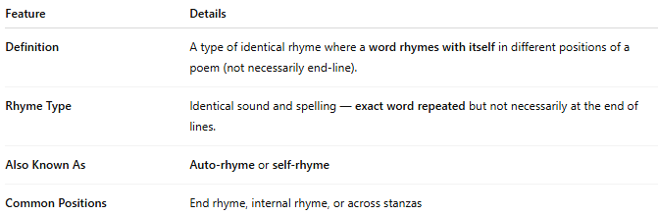
Feature | Details
Definition | A type of identical rhyme where a word rhymes with itself in different positions of a poem (not necessarily end-line).
Rhyme Type | Identical sound and spelling — exact word repeated but not necessarily at the end of lines.
Also Known As | Auto-rhyme or self-rhyme
Common Positions | End rhyme, internal rhyme, or across stanzas

📝 Examples:
# Source: Chatgpt (GPT-4-turbo) at [8/2/2025]
He said what he said — no lies were said,
And in her silence, truth was also said
The fight was over, but not the fight,
It burned in dreams throughout the night.

🎭 Effect in Poetry:
# Source: Chatgpt (GPT-4-turbo) at [8/2/2025]
- Emphasizes a central concept or emotion
- Can suggest persistence, obsession, or cyclical thought
- Builds rhythmic unity and semantic weight

🔗 Related to:
# Source: Chatgpt (GPT-4-turbo) at [8/2/2025]

Term | Relation
Repetitive Rhyme | Repeats the same word at rhyme points
Internal Rhyme | Often used when the same word appears within a line
Reflexive Rhyme | Involves variants or inflections of the same root word

✅ When to Use:
# Source: Chatgpt (GPT-4-turbo) at [8/2/2025]
- To highlight keywords or thematic ideas
- In poems or lyrics with a mantra-like or echoing structure
- To create a feeling of inevitability or emphasis on a single idea

